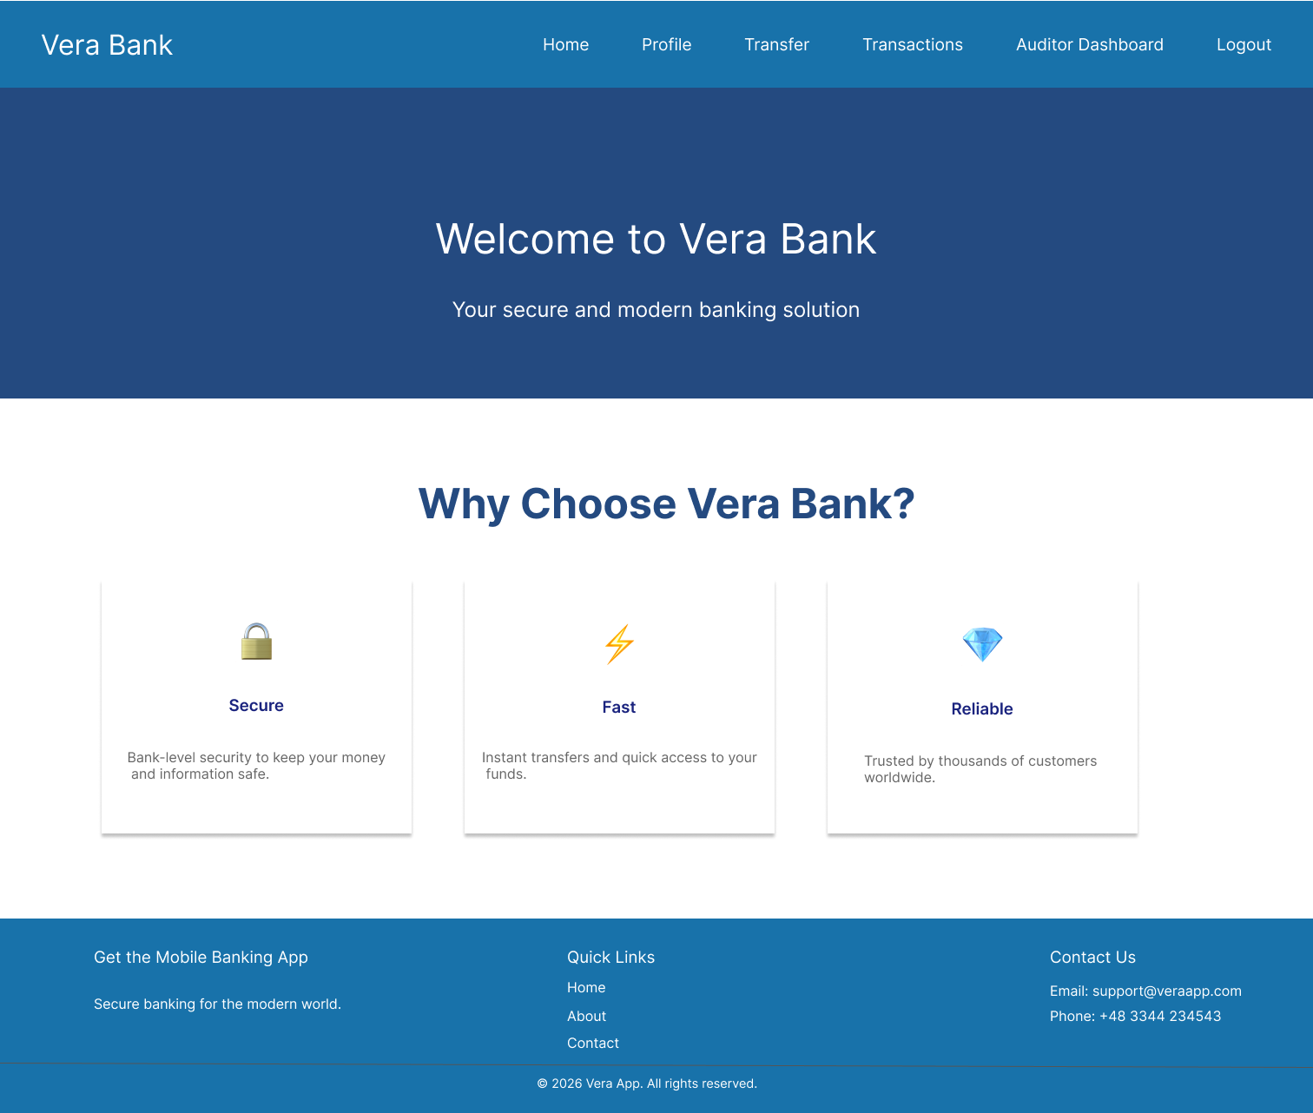
Vera Bank – Digital Account & Transaction Platform

1. 🎯 Product Overview
Vera App is a secure, scalable backend-driven platform that allows users to:
- Create and manage accounts
- Perform financial transactions
- Receive notifications
- Authenticate securely
- Manage roles and permissions
The system follows a modular architecture with:
- Frontend (UI/UX)
- Backend (business logic)
- Database (persistent storage)
- Authentication module (security layer)

2. System Architecture
Components:
- Frontend
  - User interface (web/mobile)
  - Communicates via REST APIs
- Backend
  - Core business logic
  - Handles:
    - Users
    - Accounts
    - Transactions
    - Notifications

- Authentication Module
  - Login / Register
  - Token-based auth
- Database
  - Stores all entities
  - Relational (PostgreSQL)

3. Core Modules
👤 User Management
Handles:
- Registration
- Profile management
- Role assignment
Key Fields:
- Name, email, phone
- Password (hashed)
- Roles
- Linked accounts

🏦 Account Management
Each user can have multiple accounts.
Features:
- Create account
- View balance
- Close account
- Currency handling

💸 Transaction Module
Handles money movement.
Types:
- Deposit
- Withdrawal
- Transfer
Features:
- Transaction history
- Status tracking
- Source & destination accounts

🔔 Notification Module
Sends updates to users.
Examples:
- Transaction success
- Account updates
- Security alerts

🔐 Authentication Module
Handles:
- Login
- JWT token issuance
- Password reset via code

4. 🗄️ Database Design (Entities)
User
- id
- firstName
- lastName
- email
- password
- roles (Many-to-Many)
- accounts (One-to-Many)

Role
- id
- name (e.g., ADMIN, USER)

Account
- id
- accountNumber
- balance
- currency
- status
- user (Many-to-One)

Transaction
- id
- amount
- type
- status
- sourceAccount
- destinationAccount
- date

Notification
- id
- subject
- body
- recipient (User)

PasswordResetCode
- code
- expiryDate
- used
- linked user

5. 🔄 User Flows
🧑‍💻 1. User Registration Flow
- User opens frontend
- Clicks Sign Up
- Enters:
  - Name
  - Email
  - Password
- Backend:
  - Validates input
  - Hashes password
  - Creates user
- Default role assigned: USER
- Response → Success
🔐 2. Login Flow
- User enters email + password
- Backend:
  - Validates credentials
  - Generates JWT token
- Token sent to frontend
- Stored in:
  - LocalStorage / Cookies
- User is authenticated for future requests

🔁 3. Password Reset Flow
- User clicks Forgot Password
- Enters email
- Backend:
  - Generates reset code
  - Stores in DB
- User receives code
- User submits new password + code
- Backend:
  - Validates code + expiry
  - Updates password

🏦 4. Create Account Flow
- Logged-in user clicks Create Account
- Selects:
  - Currency
  - Account type
- Backend:
  - Generates account number
  - Creates account with balance = 0
- Linked to user

💸 5. Transaction Flow (Transfer)
- User selects:
  - Source account
  - Destination account
  - Amount
- Backend:
  - Validates:
    - Sufficient balance
    - Account status
- Executes:
  - Deduct from source
  - Add to destination
- Saves transaction
- Sends notification

📊 6. View Transaction History
- User opens dashboard
- Requests transactions
- Backend:
  - Fetches user account transactions
- Returns sorted list

🔔 7. Notification Flow
Triggered when:
- Transaction completed
- Account updated
Steps:
- Event occurs
- Notification created
- Linked to user
- Sent to frontend

6. 🔐 Security Considerations
- Password hashing → bcrypt
- JWT authentication
- Role-based access control (RBAC)
- Input validation (backend + frontend)
- Rate limiting (login attempts)

- ⚙️ Tech Stack

- Backend: Spring Boot (Java), Spring Security, JWT, RESTful API Design
- Frontend: React (SPA)
- Databases: MySQL or PostgreSQL
- Security: JWT, Roles & Permissions, Customer & Auditor Routes
- DevOps & Cloud: Docker, GitHub Actions (CI/CD), Automated Deployment, AWS S3
- Features: Deposit, Withdrawal, Transfer APIs, Email Sending (SMTP), Notifications.

